Lukesland is a 24-acre family-run garden in Dartmoor National Park, on the edge of Ivybridge, in the South Hams, Devon. Set in the picturesque valley of the Addicombe Brook, Lukesland is well-loved for its wonderful range of spring and autumn flowering shrubs and specimen trees, some dating from Victorian times.
In the middle ages, tin streamers worked the valley that is now the site of Lukesland Gardens. They disturbed the entire course of the stream and left piles of stone and gravel along its sides. But this can only be seen now on the moor and fields above the garden.
There was a house in what is now the formal part of the garden, that is thought to have been Tudor. It was quite substantial (records refer to its seven bedrooms), but it disappeared from the records around the mid nineteenth century.

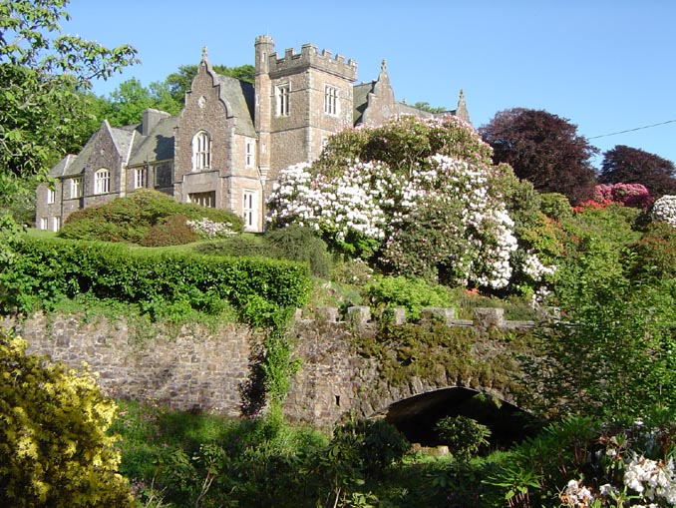
The current house was built in 1862 in the distinctive Victorian Gothic style, by W. E. Matthews. He wanted a base for hunting on the moor, but did not live here for long. Around 1875 he sold it to James and Barbara MacAndrew, who came from the family of the Liverpool shipping line of that name. They extended the house and built the Lodge at the entrance.
In 1930 the house passed to the Howell family. Over the last seventy-five years they have greatly improved the gardens, changing them from dark Victorian laurel groves to bright displays of flowering shrubs.

