WI Craft Group
Project: Drop Spindle Spinning
With Wendy
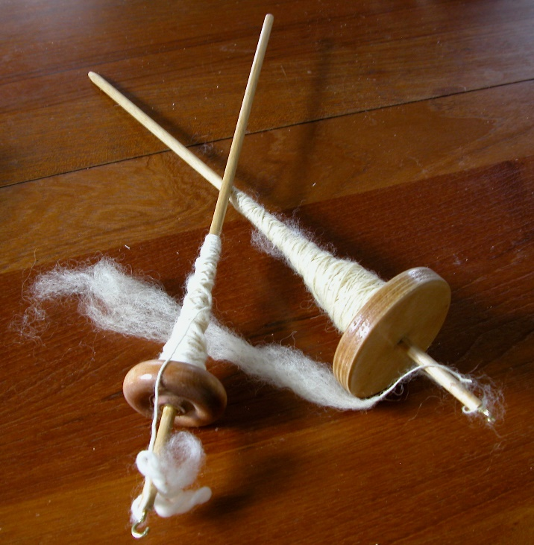

Things to Bring with you
£1.50 (hall contribution and refreshments)

Important Things
Please confirm your attendance for materials

